Техническая спецификация и архитектура
Проект «Третья рука»: C4-like схемы, ТЗ, модульная архитектура, edge/server взаимодействие
Статус | Draft v0.7
Дата | 20.03.2026
Цель документа | Зафиксировать технический контур для Stage 1 -> Stage 3 и связать его с reuse-подходом OrcaHand

1. Архитектурный принцип
Базовое решение: вся real-time логика движения и safety должна исполняться локально. Сервер нужен для телеметрии, хранения артефактов, обучения моделей, экспериментов и доставки конфигов/моделей. Это не догма ради красоты, а вывод из характера задачи: handover и shared control чувствительны к latency, user override и предсказуемости [S9][S10]. Решение v0.4: Stage 1 ориентирован на настольный dock как primary deployment target; body mount рассматривается как downstream packaging choice, проверяемый после bench validation.
Решение: Edge-first architecture. Сервер — вторичный слой. Он не должен быть single point of failure для запуска handover-сценария.
2. C4-like диаграммы
Context view: кто с кем взаимодействует и где проходит граница edge/server.
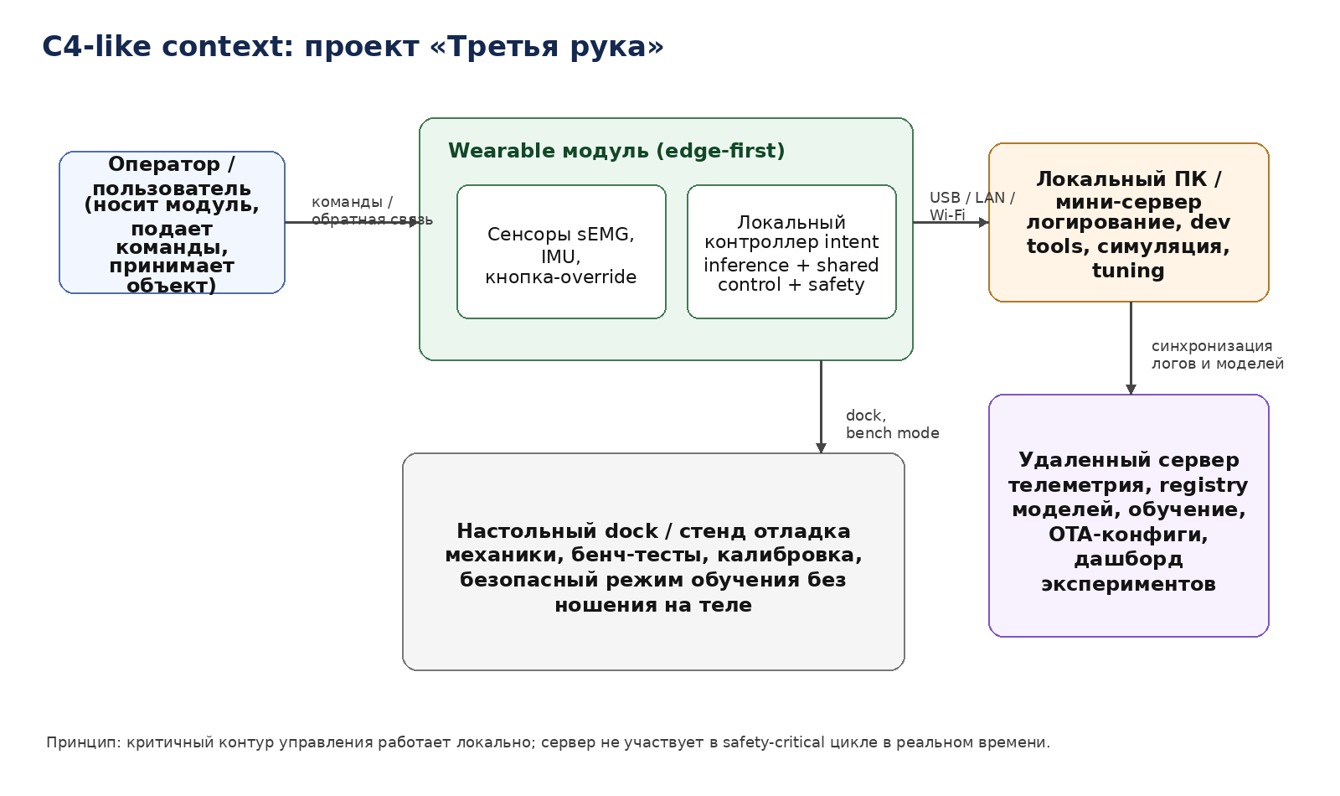

Container view: логические контейнеры внутри системы.
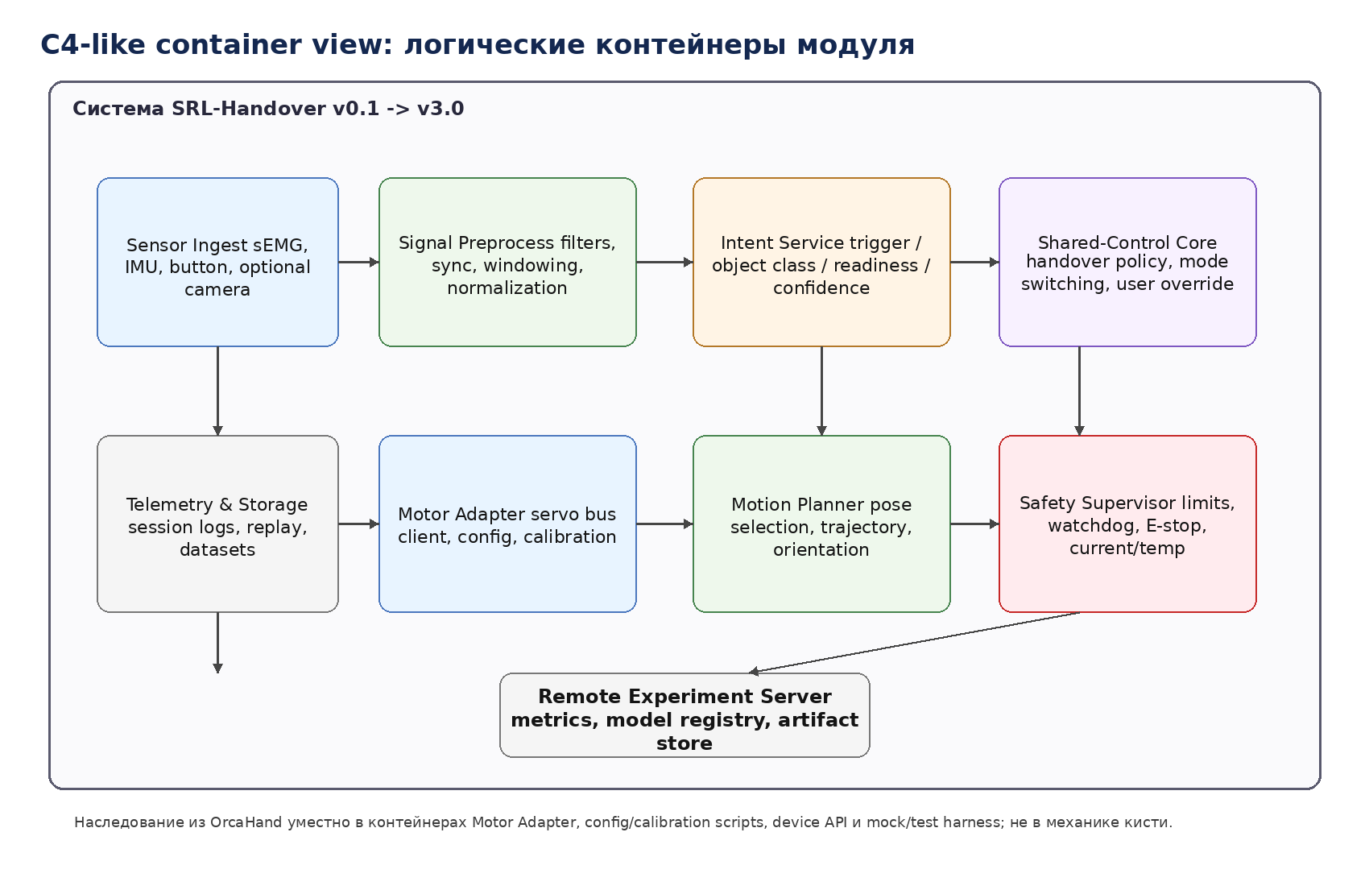

Component flow: путь сигнала от сенсоров до выдачи объекта.
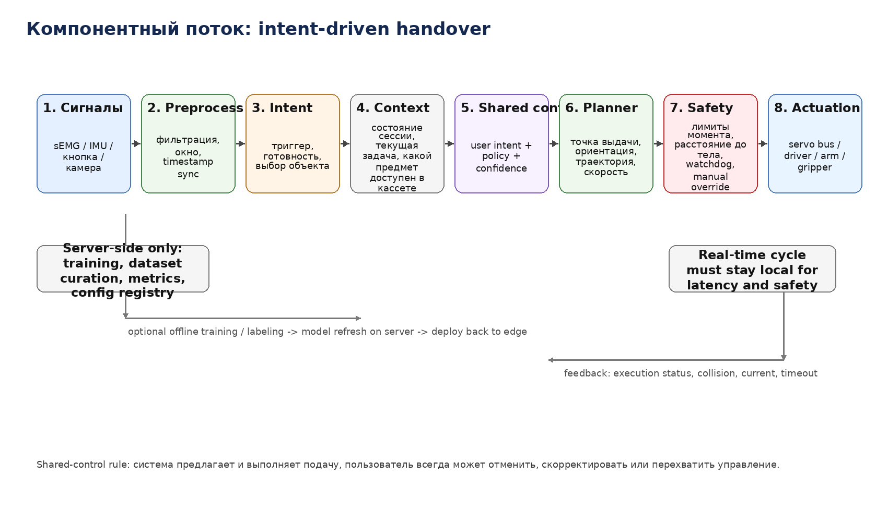

3. Логические слои системы
Слой | Назначение | Комментарий
Mechanical layer | arm core, base, wrist, gripper, cable routing, printed shells | Должен жить независимо от конкретной inference-модели
Sensing layer | sEMG, IMU, button, optional camera | Stage 1 может стартовать без vision
Control layer | preprocess, intent, shared control, motion planner, safety | Главный edge-контур
Device layer | servo bus client, calibration, config, health | Здесь OrcaHand дает наибольшую пользу
Experiment layer | logging, replay, datasets, metrics | Нужен уже со Stage 1, иначе Stage 2 будет строиться вслепую
Server layer | artifact registry, dashboards, model versions, sync | Не участвует в обязательном локальном цикле управления

4. Reuse map from OrcaHand
4.1 Direct adaptation candidates
• Device API: FastAPI + uvicorn + базовые команды connect/disconnect/status/enable torque/set joint positions/calibrate [S3][S4].
• Model folders и YAML-конфиги: отдельные папки моделей, где живут config.yaml и calibration.yaml [S2][S5].
• Hardware abstraction: motor_client + конкретные clients для Dynamixel и Feetech; mock client для bench tests [S2].
• CLI-паттерн: scripts/ для calibrate, neutral, record/replay, diagnostics [S2].
• URDF/MJCF-дисциплина: отдельный репозиторий описаний/сцен для симуляции [S6].
4.2 What must be redesigned
• Own arm model schema: joints arm_base / shoulder / elbow / wrist_yaw / wrist_pitch / gripper вместо finger joints.
• New calibration sequence for arm kinematics and dock alignment.
• Safety supervisor поверх device layer: зоны near-body, max current, max speed, collision fallback.
• Task/session context store: объект доступен где, какая фаза задачи, confidence, autonomy level.
• Handover policy и planner: этого в orca_core нет, это ядро нового продукта.
5. Initial technical assignment (ТЗ v0.1)
5.1 Scope for Stage 1
• Собрать arm core не менее чем с 3 активными степенями свободы плюс простой gripper/end-effector.
• Реализовать dock base как primary deployment target для bench режима, отладки и repeatability tests.
• Реализовать ручной trigger handover: кнопка либо gesture/IMU-pattern; на Stage 1 триггер должен работать в настольной конфигурации без body-worn wiring.
• Интегрировать как минимум 1 sEMG канал и 1-2 IMU для логирования и пилотного intent classification.
• Поддержать 3-5 заранее известных объектов в фиксированной кассете.
• Сделать safe pose, return-to-home, E-stop и watchdog.
• Записывать сессии в локальное хранилище с возможностью replay.
• Завершить Stage 1 отдельным geometry/mount study по готовому настольному core-модулю: масса, CoG, envelope, reach, interference, candidate mounts.
5.2 Scope for Stage 2
• Добавить readiness model / phase model пользователя.
• Перейти на shared control: trigger becomes optional, not mandatory.
• Сделать body-mounted wearable alpha с ограниченным payload.
• Ввести profile-based configs per user/per task.
• Поддержать offline labeling и re-training pipeline.
5.3 Scope for Stage 3
• Quick-swap dock/wearable base.
• Model registry и конфигурационный сервер.
• Сменные end-effectors и tool cartridges.
• Режимы автономии по профилю задачи.
• Накопление собственного dataset и benchmark suite.
6. Предлагаемая software architecture
Контейнер | Где работает | Функция | Исходная база
sensor_ingest | Edge SBC | Сбор sEMG/IMU/button/camera timestamps | Новое
signal_preprocess | Edge SBC | Filtering, normalization, windows, sync | Новое
intent_service | Edge SBC | Classification/regression for trigger/readiness/object request | Новое
shared_control_core | Edge SBC | Combines user intent + policy + manual override | Новое, но опирается на [S10]
motion_planner | Edge SBC | Pose selection, trajectories, velocities | Новое
safety_supervisor | Edge SBC | Limits, watchdog, near-body rules, current/temp fences | Новое
device_service | Edge SBC | HTTP API + hardware access + calibration CLI | Reuse pattern from OrcaHand [S3][S4]
telemetry_client | Edge SBC | Upload logs/config snapshots to server | Новое
experiment_server | Remote/local PC | Artifacts, models, metrics, dashboards | Новое

7. API sketch
Ниже — рабочая форма будущего device API. Она не копирует OrcaHand 1:1, но наследует его логику: состояние устройства, явные команды, отдельный config endpoint, простая калибровка и stateless HTTP-слой поверх локального control core [S4].
Method | Endpoint | Назначение | Примечание
POST | /config | Выбор модели/base/task profile | YAML/JSON config snapshot
POST | /connect | Подключить arm module | Локальный вызов
POST | /disconnect | Отключить модуль | Сначала torque off
GET | /status | Состояние edge loop, calibration, faults | Health-check
POST | /safety/estop | Аварийная остановка | Highest priority
POST | /mode | dock / wearable / replay / safe | Mode switch
POST | /handover/request | Явный запрос на подачу объекта | Stage 1 core
POST | /intent/debug | Подача тестового намерения/меток | Для bench tests
GET | /sensors/live | sEMG/IMU snapshot | Debug/inspection
POST | /calibrate | Калибровка arm/base/sensors | May take time
POST | /joints/position | Низкоуровневое движение для сервисных сценариев | Не user-facing
POST | /session/start | Старт журналирования | Links all streams
POST | /session/stop | Стоп журналирования и упаковка артефактов | Creates replay bundle

8. Data and config model
• arm_model.yaml — joints, actuator ids, limits, neutral pose, base type, payload profile.
• sensor_profile.yaml — sEMG placement, IMU ids, sample rates, filter params.
• task_profile.yaml — object set, handover zone, orientation presets, autonomy level.
• safety_profile.yaml — current limits, speed limits, workspace fences, body exclusion zones.
• session bundle — timestamps, raw sensors, inferred intent, executed trajectory, faults, user notes.
Почему именно так: Если конфиги не вынести отдельно и не версионировать, Stage 2 неизбежно превратится в набор не повторяемых «магических настроек». OrcaHand полезен как раз тем, что уже показывает дисциплину model/config folders [S2][S5].
9. Latency, reliability, safety assumptions
Параметр | Draft target | Комментарий
Intent loop frequency | 50-100 Hz | Достаточно для Stage 1/2 пилота; уточнить после выбора железа
Device command loop | 50-200 Hz | Зависит от actuator bus
Server dependency | 0 для base mode | Сервер optional при реальном handover
Manual override reaction | Максимально быстро, локально | Не должен ждать сеть/облако
Fail-safe on sensor loss | Fallback to safe pose / stop | Особенно критично для sEMG noise
On-body speed policy | Conservative by default | Body-mode медленнее dock-mode

10. Test strategy
• Bench tests: dry run without object, then with dummy objects, then with target objects.
• Replay tests: повторное воспроизведение журналов и intent streams.
• Fault injection: sensor dropout, stale command, overcurrent, disconnect, bad confidence.
• Human factors: скорость, комфорт, perceived intrusion, reachability, trust.
• Wearable tests: сначала без выдачи в руку, потом с пустым объектом, потом с реальным lightweight object.
11. Open technical decisions
ID | Решение | Текущий статус
D-01 | Actuator stack | Feetech-first для бюджетного PoC или Dynamixel-first для SDK/robustness?
D-02 | Base mount | waist/hip vs torso/shoulder as primary wearable mount
D-03 | Vision timing | camera in Stage 1 or Stage 2
D-04 | End-effector type | simple gripper vs magnetic/tool-specific holder
D-05 | Power | external PSU first vs body battery from alpha
D-06 | Compute | Pi 5 enough for Stage 1, or local mini-PC needed sooner

Источники
[S1] ETH Zurich Soft Robotics Lab: ORCA hand overview, 17-DoF tendon-driven hand, material cost below 2,000 CHF, assembly <8h, reliability claims — https://srl.ethz.ch/orcahand.html
[S2] GitHub: orcahand/orca_core repository overview and scripts for tension/calibration/neutral/test — https://github.com/orcahand/orca_core
[S3] raw pyproject.toml: orca_core depends on dynamixel-sdk, FastAPI, uvicorn, requests/httpx, numpy and targets Python >= 3.10 — https://raw.githubusercontent.com/orcahand/orca_core/main/pyproject.toml
[S4] raw api.py: device API with /connect, /status, /torque, /joints/position, /calibrate endpoints — https://raw.githubusercontent.com/orcahand/orca_core/main/orca_core/api/api.py
[S5] raw config.yaml: YAML-based motor/joint mapping, control_mode, calibration sequence — https://raw.githubusercontent.com/orcahand/orca_core/main/orca_core/models/orcahand_v1_right/config.yaml
[S6] GitHub: orcahand_description repository with URDF/MJCF and MuJoCo scene — https://github.com/orcahand/orcahand_description
[S7] CORDIS HARIA project: wearable and grounded supernumerary limbs, wearable interfaces, shared AI/user control trade-off — https://cordis.europa.eu/project/id/101070292
[S8] Frontiers 2024 review: wearable augmentations, exoskeletons and supernumerary limbs, non-invasive EEG/sEMG intent interfaces — https://www.frontiersin.org/journals/neurorobotics/articles/10.3389/fnbot.2024.1443010/full
[S9] ScienceDirect 2024 review: human-robot object handover as a core capability in collaboration — https://www.sciencedirect.com/science/article/pii/S2667379724000032
[S10] PubMed 2025: shared control for SRL improves task success and user experience vs fully autonomous or voluntary-only control — https://pubmed.ncbi.nlm.nih.gov/39996972/
[S11] ETH 3HANDS dataset: naturalistic handovers for hip-mounted SRL, intimate workspace and primary-task user — https://www.research-collection.ethz.ch/entities/publication/6aa8d0e4-f25f-41d4-9bc9-176b85b9df57
[S12] MDPI 2025 review: sEMG intention recognition is central but difficult; fusion with other signals is a major direction — https://www.mdpi.com/1424-8220/25/8/2448
[S13] ScienceDirect 2025 review: sEMG-IMU fusion improves accuracy and reliability for upper-limb movement recognition — https://www.sciencedirect.com/science/article/pii/S1566253525004956
[S14] Eckstein: Feetech STS3215 current retail price and specs — https://eckstein-shop.de/Feetech-STS3215-74V-19kgcm-plastic-case-metal-gear-magnetic-code-dual-shaft-TTL-serial-servo
[S15] BerryBase: Waveshare ST/SC serial bus servo adapter board current retail price — https://www.berrybase.de/en/waveshare-serial-bus-servo-adapter-board-253-st-sc-series-controller-for-robot-arm-hexapod
[S16] BerryBase: Raspberry Pi 5 8GB current retail price — https://www.berrybase.de/en/raspberry-pi-5-8gb-ram
[S17] Antratek: MyoWare 2 sensor current retail price — https://www.antratek.de/myoware-2-0-muscle-sensor-basic-kit
[S18] BerryBase / DigiKey: BNO085 breakout and chip current retail price — https://www.berrybase.de/en/adafruit-9-dof-orientation-imu-fusion-breakout-bno085-bno080
[S19] MyBotShop / pib.Shop / Luxonis: OAK-D Lite current retail price — https://www.mybotshop.de/Luxonis-DepthAI-OAK-D-Lite_1
[S20] MyBotShop/Reichelt/Funduino: ROBOTIS U2D2 current retail price — https://www.mybotshop.de/ROBOTIS-DYNAMIXEL-U2D2_1
[S21] ROBOTIS XM430-W350-T official specs and price — https://en.robotis.com/shop_en/item.php?it_id=902-0124-000
[S22] ROBOTIS / MYBOTSHOP: XL330-M288-T official specs and retail price — https://en.robotis.com/shop_en/item.php?it_id=902-0163-000

v0.2 — Архитектурные уточнения после выбора payload и object set
Ниже зафиксированы изменения, которые должны повлиять на механику, safety envelope и server/edge границу.
- System class for Stage 1: rigid-object wearable-first handover assistant with docked bench mode.
- Primary Stage 1 objects: mug, flashlight, ball. Secondary objects: marker, screwdriver.
- Deformable objects (towel, cord) are excluded from Stage 1 and Stage 1.5 architecture assumptions.
- Vision is added in Stage 1.5 as a non-safety-critical perception module; Stage 1 remains trigger-driven without scene reasoning.
- Quick-change tool-side is postponed, but mechanical/electrical interface reservation is required in arm core.

Updated safety envelope
- Nominal payload mode: up to 300 g object mass with conservative acceleration.
- Stretch mode: up to 500 g only at reduced velocity and short reach envelope.
- Mug scenario is approved only as empty mug or closed-lid mug in Stage 1 unless spill-safe tests are passed.
- No cloth, rope, towel or dangling cable handling in Stage 1 baseline.
- Wearable mode must allow emergency stop, manual override and passive safe pose fallback.

Mounting trade study to be performed before hardware freeze
Вариант | Плюсы | Риски | Статус
Пояс/бедро | ниже центр масс, проще надеть | может мешать походке и рабочей зоне | исследовать
Рюкзак/спина | лучше для батареи и heavier core | сложнее кинематика и доступ к зоне подачи | исследовать
Плечо/торс | короче путь до руки пользователя | выше burden и выше требования к безопасности рядом с шеей/лицом | осторожно

Server interaction refinement
- Server still stays out of real-time control loop.
- Stage 1.5 vision inferences may run locally on edge and sync metadata/models to server asynchronously.
- Object profiles should be represented as typed recipes: mass range, preferred grasp pose, delivery orientation, safe speed cap.
- Future quick-change end-effectors should be exposed as capability profiles, not hard-coded device branches.

v0.3 — Технические уточнения по Stage 1 / 2 / 3
- Tool-side strategy: Stage 1 использует один фиксированный utility end-effector, но arm core обязан иметь заранее предусмотренный mounting pattern и reserve space под future electrical contacts / quick-release. Stage 2 вводит manual swap end-effectors. Stage 3 вводит полноценный quick-change tool-side.
- Stage 1 handover default: режим A — object is brought to pickup zone and held stable. Stage 1 stretch: режим C — object moved to fixed handover waypoint near dominant hand. Режим B откладывается до Stage 2, когда появятся readiness estimation, lower-speed final approach и более тонкий release policy.
- Рабочий reach для v1: 30–35 см от базовой точки выдачи. Дальнейшее увеличение только после валидации torque budget и burden near body.
- Cup handling policy: first-pass object model = empty cup; slightly-filled cup allowed only as stretch test with reduced speed profile and spill-safe posture assumptions.
- Proto-industrial design: корпуса и крышки должны быть аккуратными уже в Stage 1, но cosmetic shells не должны мешать обслуживанию, доступу к проводке и ревизии приводов.

Обновление ТЗ Stage 1
- Обязательная дальность handover: 30–35 см.
- Обязательный default сценарий: поднести и удерживать объект в pickup zone.
- Желательный stretch сценарий: вывести объект в фиксированный waypoint рядом с правой рукой.
- Пилотные объекты: пустая кружка, фонарик, мячик.
- В Stage 1 не требуется полноценный quick-change; требуется лишь стандартный интерфейс крепления будущих end-effectors.

Изменения v0.4
- Primary deployment for Stage 1 = desktop dock. Edge stack, safety supervisor and planner отлаживаются без телесного mount.
- Mount architecture на Stage 1 держится как interface contract: arm core должен иметь точки крепления и кабельный запас, но финальная wearable base не фиксируется.
- Mount study становится отдельным technical gate перед Stage 2.
10. Architectural delta v0.5 — split powered-base strategy
Новая фиксация архитектуры: arm core переиспользуется между режимами, но base modules не унифицируются как одинаковый корпус. Унифицируется интерфейс между arm core и base module: mechanical lock, power bus, comms bus, emergency line.
- Common interface contract: arm-core flange + 1 power connector + 1 data connector + fast detach lock.
- Desktop Dock Module responsibilities: fixed bench mount, stable footprint, optional external PSU or dock battery, compute host, logging and calibration station.
- Wearable Mount Module responsibilities: body-safe mounting frame, cable routing, soft interfaces to body, optional separated battery/computer pack, emergency quick release.
- Low-level safety remains on arm/edge controller; body-mode must not depend on server or on dock-resident software for stop behavior.
Причина такого split: mounting position, link lengths и arm burden критически меняют usable workspace в wearable robotics, а тяжелые батареи и масса в основании полезны для stability на стационарной платформе, но не переносятся напрямую на тело без ухудшения ergonomics и acceptance.

12. Server interface, uplink and programming path
Northbound interface between base module and server is intentionally separated from southbound motion/control interfaces. The server is not allowed to bypass local safety and talk directly to actuator buses.
12.1 Recommended connectivity model
- Southbound (arm core ↔ base module): platform contract from v1.0 — 24 V main rail, CAN-based external module bus, hardwired NC safety loop, presence/interlock lines.
- Local edge compute/gateway on desktop dock: Raspberry Pi 5 class SBC. It already provides Gigabit Ethernet, dual-band 802.11ac Wi‑Fi and Bluetooth/BLE, so no отдельный Wi‑Fi module не обязателен для Stage 1 при выборе Pi 5 [S33].
- Northbound (base module ↔ server): два режима. (a) Bench/service mode — Ethernet or direct local connection for programming and diagnostics. (b) Wireless ops mode — Wi‑Fi uplink for telemetry, dashboard, config sync and non-critical “brain” services.
- Optional wearable successor: CM5-class module with optional Wi‑Fi/Bluetooth [S34][S35]. Это полезно, если в Stage 2/3 desktop Pi 5 станет слишком большим для body-side packaging.
- Device API northbound: HTTPS/REST for configs, jobs, artifacts and logs ingestion; WebSocket stream for live status/events/operator UI. This mirrors the existing FastAPI-friendly software direction and keeps implementation complexity low [S36].
- Local persistence: ring buffer + append-only session bundles on edge. Server outages must not break tests; sync is eventually consistent.
- Programming path: default programming over Ethernet/USB service access in Stage 1; OTA package pull over Wi‑Fi allowed later, but only after signed/versioned update flow is in place.
12.2 Practical recommendation by stage
- Stage 1: use Ethernet as primary dev/debug path, keep Wi‑Fi enabled for convenience, dashboards and log upload.
- Stage 1.5: add Wi‑Fi-based telemetry and live operator page once base handover loop is stable.
- Stage 2: if wearable alpha is built, keep local autonomy on-device and treat Wi‑Fi as supervisory link only.
- Stage 3: move toward formal config/model registry and remote fleet-style management, still without putting real-time motion in the server path.
12.3 Sources added for v0.6
[S33] Raspberry Pi 5 official product page: Gigabit Ethernet, dual-band 802.11ac Wi‑Fi, Bluetooth 5.0/BLE — https://www.raspberrypi.com/products/raspberry-pi-5/
[S34] Raspberry Pi documentation: Raspberry Pi computer hardware connectivity summary — https://www.raspberrypi.com/documentation/computers/raspberry-pi.html
[S35] Raspberry Pi Compute Module 5 official page / docs: CM5 with wireless options — https://www.raspberrypi.com/products/compute-module-5/ ; https://www.raspberrypi.com/documentation/computers/compute-module.html
[S36] FastAPI WebSocket docs — https://fastapi.tiangolo.com/advanced/websockets/

13. Northbound Protocol Contract v1.0
Contract относится к связи base module / local edge compute с сервером и внешними приложениями. Он отделен от southbound motion/control interfaces и не должен участвовать в safety-critical real-time loop.
13.1 Chosen pattern
- Mandatory baseline: HTTPS/REST + WebSocket.
- Planned extension: MQTT telemetry/event bus from Stage 1.5/2+ when multi-client subscriptions or decoupled event processing become useful.
- Reference deployment for Stage 1: FastAPI service on local edge compute; REST for jobs/config/artifacts, WebSocket for live telemetry/events/operator channel.
13.2 Message families
- status - current mode, lifecycle state, arm present, latch state, network state, current job.
- telemetry - sampled summaries from joints/sensors/intent/confidence, battery/power, temperatures, watchdog counters.
- event - discrete domain events: homed, handover_started, object_ready, fault_raised, estop_pressed, sync_complete.
- command/job - high-level operations only: start_session, stop_session, home, calibrate, handover_request, export_logs, apply_config.
- artifact/config/model - versioned configs, model files, session bundles, replay files, calibration profiles.
- fault - structured alarms with code, severity, source, timestamp, recommended action.
13.3 Hard boundaries
- Server cannot send raw joint/motor commands into actuator bus.
- Loss of northbound link must not prevent local stop, return-to-safe-pose or session completion policy.
- Local queue/spool is mandatory for logs and events when uplink is absent or unstable.
- Northbound auth/versioning may evolve, but message schema stability is required once Stage 1 API is frozen.
13.4 Stage mapping
- Stage 1: REST + WebSocket only; MQTT optional and normally omitted for the fastest first result.
- Stage 1.5: add basic vision and, if needed, MQTT topics for telemetry/events consumed by separate UI/logging services.
- Stage 2: keep local autonomy on edge, treat northbound as supervisory/control plane; MQTT becomes justified if event fan-out appears.
- Stage 3: formalize config/model registry, replay pipelines and remote orchestration while keeping real-time motion local.

9. Stage 1 API and message contract freeze (v0.8)
Базовый принцип. HTTP-слой документируется через OpenAPI, а event-driven слой WebSocket/MQTT — через AsyncAPI. Это разделяет request/response и message-driven части без дублирования схем.
9.1 Recommended JSON envelope
{
"schema_version": "1.0",
"msg_type": "telemetry | event | fault | ack",
"msg_name": "handover.completed",
"ts": "2026-03-21T18:42:10.123Z",
"source": "edge.desktop.alpha1",
"session_id": "sess_01",
"seq": 1842,
"payload": {}
}
9.2 Stage 1 WebSocket stream
Channel | Direction | Payload families | Notes
/ws/stream | server -> client | status, telemetry, event, fault, ack | Single multiplexed stream; simpler reconnect
/ws/stream | client -> server | operator command envelopes (optional later) | Stage 1 may keep commands on REST only
9.3 Stage 1 command semantics
Command | Input | Synchronous response | Async side effect | Priority
session.start | profile_id, operator, notes | 202 Accepted + command_id | event: session.started | must
arm.home | none / pose id | 202 Accepted + command_id | event: arm.homed / fault | must
arm.calibrate | calibration_mode | 202 Accepted + command_id | event: arm.calibrated / fault | must
handover.request | object_id, source_slot, present_mode | 202 Accepted + command_id | events: started, grasped, presented, completed | must
arm.safe-stop | reason | 202 Accepted + command_id | event: arm.safe_stopped | must
arm.reset-fault | fault scope | 200/202 | event: fault.cleared | must
9.4 MQTT-compatible topic schema (reserved)
- thirdarm/{device_id}/status
- thirdarm/{device_id}/telemetry
- thirdarm/{device_id}/events
- thirdarm/{device_id}/faults
MQTT не обязателен в Stage 1. Схема резервируется заранее, чтобы позже подключить broker без переосмысления message families.
9.5 Implementation notes for FastAPI edge service
- REST handlers должны возвращать command_id и не блокироваться на полный жизненный цикл handover.
- WebSocket stream должен нести только нормализованные сообщения, а не сырые servo packets.
- Replay/logging пишет ровно те же envelopes, что идут в /ws/stream, чтобы не плодить второй формат.
- Внутренний southbound слой может использовать иной transport и иную частоту обновления; northbound должен отдавать агрегированную, стабильную картину.

13. Stage 1 handover state machine (frozen in v0.9)
Ниже фиксируется практическая state machine, на которую должны опираться edge runtime, REST-команды, WebSocket events, replay bundle и fault handling. Она должна быть реализована как явный конечный автомат, а не как набор неформальных флагов.
State | Entry conditions | Allowed commands | Emitted events | Exit conditions | Notes
boot | Process start, config file present | GET /health | system.booting | self_check | No motion allowed
self_check | Arm present, latch readable, safety loop evaluable | GET /status | system.self_check.started; passed/failed | idle or fault | Checks power, config, interlocks
idle | Service up, motion not yet armed | POST /session/start; POST /arm/home | system.idle | homing | Can remain idle indefinitely
homing | Home sequence requested and interlocks valid | POST /arm/safe-stop | arm.homing.started/completed | ready | Must end in known neutral pose
ready | Home complete, no active task | POST /handover/request; POST /arm/safe-stop | arm.ready | task_arming | Only state that accepts task start
task_arming | Valid request received, source slot/object selected | POST /handover/cancel | handover.request.accepted | acquire or task_aborted | Rejects invalid slot/object/profile
acquire | Trajectory to slot approved | POST /handover/cancel | object.acquire.started; object.grasped | lift | Verifies grasp success / timeout
lift | Object grasped and slot egress planned | POST /handover/cancel | object.lifted | present | Reduced speed in stretch payload mode
present | Handover pose planned | POST /handover/cancel | object.presented | transfer_wait | Handover zone is fixed in Stage 1
transfer_wait | Object is presented in user zone | POST /handover/cancel | handover.transfer_wait | release or task_aborted | Wait criteria later become richer in Stage 2
release | Transfer criterion satisfied | — | handover.release.started/completed | retract | May fall back to abort on unsuccessful transfer policy
retract | Object released or abort path chosen | — | arm.retract.started/completed | task_complete or ready | Returns to safe/neutral pose
task_complete | Scenario marked successful | — | handover.completed | ready | Session store updated
task_aborted | Operator/system canceled task without fault | POST /handover/request after reset to ready | handover.aborted | ready or idle | Must be distinguishable from fault in logs
safe_stop | Controlled stop requested or guard triggered | POST /session/stop; POST /arm/reset-fault per policy | arm.safe_stop.entered | idle or recovering | Not equal to hard fault
fault | Runtime fault detected | POST /arm/reset-fault | fault.raised | recovering | No normal commands accepted
recovering | Reset / re-check sequence in progress | POST /arm/home | fault.cleared; system.recovering | idle or homing | May return to fault if checks fail
shutdown | Session/service stop | POST /session/stop | system.shutdown | — | Persist logs before exit
Implementation rules for edge runtime:
- Состояния system и task должны храниться раздельно, даже если реализованы в одном runtime store.
- Каждый transition публикуется как event и дублируется в append-only session bundle.
- Commands, недопустимые в текущем state, должны отвечать отказом уровня API, а не неявным no-op.
- Fault path должен иметь нормализованный fault_code и recoverable flag.
- В MQTT-ветке эти же event envelopes могут публиковаться без изменения payload schema.
14. Object slot model and perception architecture (frozen in v0.10)
Stage 1 использует slot-first architecture. Slot registry является source of truth для geometry, support surface, allowed object types и базовых grasp/present profiles. Начиная со Stage 1.5 система получает observation layer, который может корректировать nominal pose. К Stage 2 perception loop работает постоянно и становится обязательной частью runtime.
Frozen domain entities:
- ObjectType {object_type_id, geometry_class, bounding_dims_mm, mass_g_nominal, grasp_family, allowed_handover_modes}
- SlotDefinition {slot_id, slot_type, parent_frame, nominal_pose, support_surface_id, allowed_object_types, occupancy_sensor_mode, enabled}
- PlacementProfile {object_type_id, allowed_yaw_range, upright_required, pickup_pose, pre_pick_offset, post_pick_retreat, present_pose, release_rule}
- RuntimeSlotState {slot_id, occupied, observed_object_type, confidence, last_seen_ts, last_pick_result, fault_flag}
Perception strategy options considered:
Option | Summary | Pros | Why not chosen as sole strategy
A. Fixed slots only | Only nominal slot poses; no observation layer. | Fastest and simplest Stage 1 implementation. | Creates a dead-end for Stage 2 and does not satisfy mandatory vision goal.
B. Hybrid layered perception (chosen) | Slot registry stays primary; observation layer refines pose and occupancy; later continuous vision loop becomes standard. | Best fit for desktop-first rollout; debuggable; scalable into Stage 2/3. | Slightly more schema work up front.
C. Real-time scene-first from Stage 2 with no slot priors | Markerless detection/tracking drives object selection and pose continuously. | Most flexible long-term vision story. | Higher compute, more failure modes, weaker debuggability, and unnecessary risk immediately after Stage 1.
Chosen v0.10 architecture: Variant B. Stage 1 uses semantic slots. Stage 1.5 adds observation overlay. Stage 2 makes continuous vision mandatory, but still consumes object library and slot priors where available. Stage 3 may operate scene-first, while preserving slot mode as fallback.
Recommended progression for known objects: fixed printable fixtures → fiducial-assisted pose refinement / slot validation → markerless 6DoF pose estimation and tracking for selected objects.
Northbound impact: telemetry must be able to publish nominal pose, observed pose, effective pose, observation confidence, occupancy state and perception mode.
Runtime rule: if observation is unavailable or low-confidence, Stage 2 may fall back to slot prior within configured tolerances; Stage 3 may choose between hybrid and scene-first modes based on confidence gating.

14. v0.11 — Logging / Replay Bundle Contract v1.0
The chosen architecture separates lightweight structured application trace from high-volume timestamped streams. This keeps Stage 1 simple while preserving a direct path to multimodal replay in Stage 2.

14.1 Canonical bundle layout
File / folder | Purpose | Stage 1 requirement
manifest.json | Bundle index: IDs, timestamps, result, versions, file map, replay capabilities | Must
config_snapshot.yaml | Effective edge configuration at session start | Must
slot_model_snapshot.yaml | Frozen slot, placement, and source-slot semantics used in run | Must
object_library_snapshot.yaml | Object types and grasp metadata active in run | Must
calibration_snapshot.yaml | Calibration profile used in run | Must
session_trace.ndjson | Commands, events, faults, state transitions, operator actions | Must
telemetry.mcap | Timestamped runtime streams and later perception channels | Must
artifacts/ | Optional screenshots, debug exports, notes, later vision files | Optional
checksums.txt | Integrity verification | Should

14.2 Stream allocation rules
- NDJSON holds semantic application trace. MCAP holds time-series and multimodal runtime data.
- Northbound status / telemetry / event / fault messages must be serializable into bundle records without lossy remapping.
- Vision channels added in Stage 1.5/2 attach to telemetry.mcap as new channels, not as a replacement for the bundle contract.
- Replay can reconstruct state-machine flow, slot/object context, and timing relationships from bundle contents.

14.3 Minimal replay modes
- Analytical replay: timeline inspection of commands, transitions, telemetry, and faults.
- Functional replay: deterministic control-plane re-run against recorded session inputs and state trace.
- Physical simulation is out of scope for Stage 1.

15. v0.12 — Sensor / operator input architecture
Stage 1 uses explicit operator-triggered control instead of inferred intent. The edge stack must support web UI trigger, physical trigger input, and hard emergency stop as first-class control surfaces.
Camera is reserved structurally and electrically from Stage 1. Runtime vision is deferred to Stage 1.5 for observation overlay and becomes mandatory in Stage 2 as a continuous hybrid perception loop.
IMU is the preferred early body-side sensing channel for experiments. sEMG is preserved as a later multimodal input and must not be made the only Stage 2 control path.

15.1 Control/input channels by stage
Channel | Stage 1 | Stage 1.5 / 2 | Notes
Web UI / REST + WS | Required | Required as fallback/service | Primary dev and supervisory interface
Physical trigger / footswitch | Required | Required | Hands-busy friendly command path
Emergency stop | Required | Required | Hardwired safety path, not software-only
Camera | Reserved / recommended purchase | Active from 1.5, mandatory in 2 | Continuous vision in Stage 2
IMU | Optional dev hook | Recommended working side-channel | Good early fusion input
sEMG | Deferred / R&D only | Limited scenarios in 2, stronger in 3 | Placement- and calibration-sensitive

15.2 Recommended camera strategy
If budget allows only one camera purchase, prioritize a robotics-ready device that can serve Stage 1.5 and Stage 2 without replacement. If budget is tight, keep a camera-ready mount and cable path in Stage 1 and defer the heavier vision stack to Stage 1.5.

16. v0.13 — Procurement flexibility and implementation entry
BOM freeze accepted with controlled substitution policy. Equivalent market substitutions are allowed when they preserve interface contract v1.0, power/safety assumptions, logging/replay contract, and Stage 1 operator-triggered behavior.

16.1 Substitution policy
- Compute substitutions are allowed only if they preserve local REST + WebSocket edge service, session bundle writing, and camera-ready support.
- Camera substitutions are allowed if they preserve the Stage 1.5 path to observation overlay and Stage 2 path to continuously running vision.
- IMU substitutions are allowed if they provide orientation/fusion outputs or raw inertial data with a sane integration path.
- sEMG substitutions must remain outside the Stage 1 critical path.

16.2 Implementation entry sequence
- Entry 1: edge API skeleton and WS stream.
- Entry 2: replay bundle writer and file rotation policy.
- Entry 3: slot model loader and task/state schema validation.
- Entry 4: mock arm adapter and deterministic state-machine replay.
- Entry 5: hardware bring-up with power, E-stop, trigger, dock, and first neutral motion.
- Entry 6: first closed-loop present_hold demo with one approved object class.

